Project Design Phase

Solution Architecture

|  |  |
| --- | --- |
| Date | 19 June 2025 |
| Team ID | LTVIP2025TMID51764 |
| Project Name | ShopSmart: Your Digital Grocery Store  Experience |

Solution Architecture:

The solution architecture of ShopSmart is structured to address the business need for a seamless, scalable, and efficient online grocery shopping experience. The architecture effectively connects user-facing interfaces with backend services and data storage systems to ensure responsive and secure operations for customers, sellers, and administrators.

Key Goals of the Architecture:

* Identify the best-fit technology stack (MERN) to address the core challenges of traditional grocery shopping.
* Design a robust system capable of handling dynamic user roles and real-time operations.
* Define component interaction, data flow, and modular responsibilities across the system.
* Ensure maintainability, scalability, and performance optimization in a live ecommerce environment.

Architecture Layers and Components:

1. Frontend Layer (React.js):

o Provides dynamic and interactive UI for different user roles (Customer, Seller, Admin). o Implements responsive design using modern libraries to support both mobile and desktop. o Integrates features like product listings, search filters, shopping cart, login/register, and order history.

1. Backend Layer (Node.js + Express.js):
   * Acts as the central API layer handling all HTTP requests from the frontend. o Uses Express routes and controllers to manage business logic like authentication, cart updates, product CRUD operations, and order processing. o Implements JWT-based authentication and middleware for secure and role-specific access control.
2. Database Layer (MongoDB):
   * Stores structured collections for Users, Products, Orders, Admins, and Carts. o Supports flexible document-based storage, enabling quick updates and retrievals for dynamic shopping behavior. o Integrated using Mongoose ODM to simplify queries and enforce data validation rules.
3. Authentication & Authorization:
   * JWT tokens are issued on login and stored in frontend localStorage. o Tokens are validated on every API call to ensure secure access. o Access is controlled through roles: Customers access user features, Sellers manage inventory, and Admins oversee the entire system.
4. Real-Time Operations:
   * Cart state, product availability, and admin dashboards reflect live updates.
   * Orders are tracked post-placement, with confirmation sent via email/SMS.
5. Deployment and Scalability:
   * Designed for local development (localhost:3000/frontend, 5000/backend) and scalable cloud deployment. o Modular folder structure and reusable components allow for easy feature expansion and scaling to additional regions or product categories.
6. Error Handling and Security:
   * + API endpoints are protected with authentication middleware.
     + Server errors are caught and handled gracefully, with appropriate status codes and user feedback.
     + Passwords are hashed using bcrypt for secure storage.

Technical Architecture:

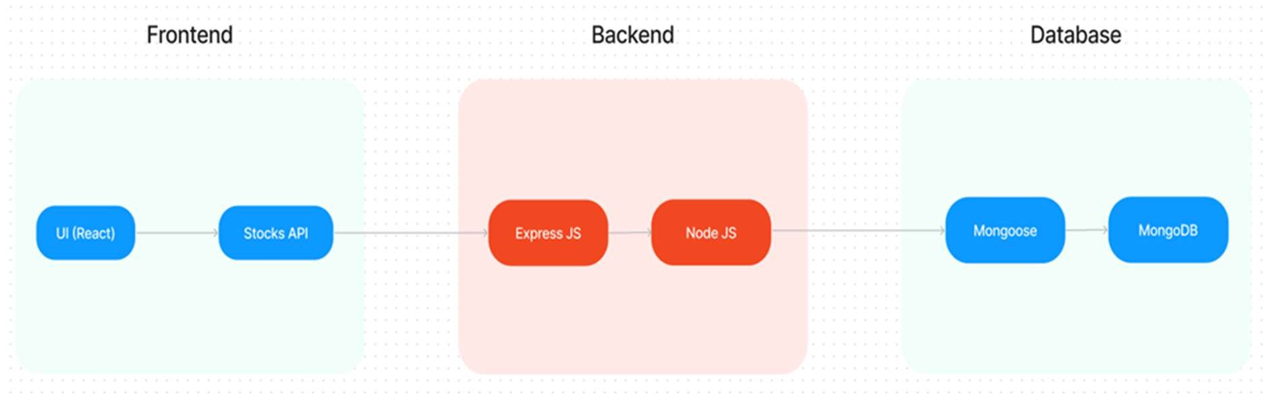

Solution Architecture:

